
DEPARTMENT OF COMPUTER SCIENCE
FACULTY OF COMPUTING & ARTIFICIAL INTELLIGENCE

Project Report
Digital Logical Design
EE123

Degree Program: BS CS
Semester: 2nd Semester
Department: BSCS (B)

Title: 16-bit Computer

Main Page
- Project Title:
16-Bit Computer

- Group Members:
  - Ahmad Rayan Qasim – 243557
  - Abdul Kabir Syed - 243581
  - Attique Alvi - 243521
  - Abdul Samad - 243597

- Supervisor: Prof Mughees Ahmad

Evaluation Sheet:

Roll# | Names | Report  (15%) | Correction  (10%) | Complete  (10%) | Concept/Understanding  (20%) | Grip  (15%) | Circuit  (30%) | Total  (100%)
243521 | Attique  Alvi
243577 | Ahmad Rayan Qasim
243597 | Abdul Samad
243581 | Abdul Kabeer  Syed

Table of Contents
Contents
Title: 16-bit Computer 1
Main Page 2
Table of Contents 4
1. Abstract 5
2. Introduction 5
3.Problem Statement: 6
5. Tools Used 6
6. Theoretical Background: How a 16-bit Computer Works 6
7. Full Workflow Table of the Project 7
8. Project Design Overview 7
9. Component Details (with Screenshots) 10
9.1 ALU (Arithmetic Logic Unit) 10
9.2 Registers 11
9.3 Program Counter 14
9.4 RAM 15
9.5 Control Unit 16
9.6 Clock 16
10. Working Explanation 17
11. Results 18
12. Conclusion 18
13. Future Work 19
14. References 19

1. Abstract
In this project, we built a simple 16-bit computer using a software called Logisim Evolution. Instead of using ready-made processors, we designed everything from scratch using basic digital components like logic gates, flip-flops, and registers. Our main goal was to understand how a computer works on the inside — how it stores information, processes data, and follows instructions step by step.
The computer we made can do basic tasks like adding or subtracting numbers, doing logical operations (like AND and OR), and running small programs saved in its memory (RAM). We created and connected different parts of the computer, such as the ALU (Arithmetic Logic Unit), registers, program counter, and a simple control unit, all of which work together to process each instruction.
This project really helped us understand how real computers work at the hardware level. It was not just about drawing circuits — it was about learning how each tiny part plays a role in running a full program. Doing this gave us hands-on experience and made digital logic design clearer and more interesting for all of us.

2. Introduction
Digital Logic Design (DLD) is the basic building block of all computer systems. It teaches us how computers work at the most basic level — using 1s and 0s. Every modern device, from mobile phones to laptops, is built on the same core logic made up of simple components like gates, flip-flops, and memory circuits.
In this project, we created and simulated a 16-bit computer using Logisim Evolution, a tool that allows us to design and test digital circuits. Instead of using advanced or hidden components, we built everything step by step — just like how computers were designed in the early days.
Our computer includes all the main parts that are needed to run a program:
- An ALU (Arithmetic Logic Unit) to perform calculations and logic operations
- Registers to hold temporary data
- A Program Counter to keep track of which instruction to run next
- RAM to store data and the program itself
- A Control Unit to manage the flow of operations
- A Clock
Together, these parts allow our computer to fetch instructions, understand them, and carry them out — similar to how real computers process programs. This project helped us learn how each small part plays a big role in making the computer work, and how everything works together like a team to perform tasks.

3.Problem Statement:
Understanding how a computer works at the hardware level can be challenging for students, as modern systems hide much of the complexity behind pre-built processors and advanced abstraction layers. This project addresses that challenge by designing a simple 16-bit computer entirely from basic digital logic components, such as logic gates, flip-flops, multiplexers, and memory units, using the Logisim Evolution simulator. By building each part from scratch—including the ALU, registers, program counter, RAM, control unit, and clock—we aimed to visualize and understand the full instruction cycle (fetch, decode, execute, store) in action. This hands-on approach helps bridge the gap between theory and practice, giving students a clearer understanding of how real processors operate and how digital circuits come together to form the foundation of every computing system.
4. Project Objectives
- To design a working 16-bit computer using digital logic components
- To simulate arithmetic and logic operations
- To build a complete instruction execution cycle: fetch, decode, execute, store.
- To simulate the design using Logisim Evolution.
- To better understand how real CPUs are built.

5. Tools Used
Primary Tool: Logisim Evolution
- Digital circuit simulation software.
- Used to design and connect components: gates, flip-flops, memory blocks, etc.
- Supports step-wise simulation using clock signals.
- Allows loading RAM with custom programs.
Other Tools:
- Snipping Tool (Windows) – for taking circuit screenshots.
- MS Word – for writing documentation.
Hardware: None (Simulation Only)

6. Theoretical Background: How a 16-bit Computer Works
A computer processes binary data using logic gates and memory elements. Here’s how it works in simple terms:
- Binary Representation: All data is stored as 1s and 0s.
- Registers: Store temporary values.
- ALU: Performs math and logic.
- Control Unit: Decides what to do next.
- Clock: Tells the system when to move to the next step.
In our 16-bit computer, every instruction follows a cycle:
- Fetch instruction from memory.
- Decode to understand the command.
- Execute the operation (via ALU or memory access).
- Store the result if needed.

7. Full Workflow Table of the Project
Step | Action | Component Involved | Description
1 | Start clock cycle | Clock | Generates timing signals for the entire circuit
2 | Point to instruction | Program Counter (PC) | PC sends address to RAM
3 | Fetch instruction | RAM | Sends instruction at address to Control Unit
4 | Decode instruction | Control Unit | Decides whether to load/store or use ALU
5 | Execute logic/arithmetic | ALU, Registers | Performs operations like ADD, SUB, AND, OR
6 | Store result | Register/RAM | Saves result as per instruction
7 | Move to next instruction | PC, Clock | Increments PC, next clock cycle starts

8. Project Design Overview
To build our 16-bit computer, we designed and connected several important parts that work together to process instructions, perform tasks, and manage data — just like in a real computer, but in a simplified way.
Here are the main components we used:
- ALU (Arithmetic Logic Unit):
This is like the brain of our computer where all the math and logic happens. It can add, subtract, and perform logical tasks like AND and OR. Whenever the computer needs to solve something, it sends the job to the ALU.
- Registers:
These are small storage areas used to hold data temporarily. For example, when you're doing a calculation, the values are first stored in registers before being processed.
- Program Counter (PC):
This part keeps track of which instruction comes next. It acts like a pointer that moves forward step-by-step as the computer runs each line of the program.
- RAM (Memory):
RAM holds the program that we want to run and the data the program needs. It’s like a notepad the computer uses to read instructions and store information.
- Control Unit:
This is the manager of the computer. It reads the instruction from memory, decides what needs to be done, and tells all the other parts (like the ALU, RAM, and registers) what to do next.
- Clock:
The clock keeps everything in sync. It sends regular signals to make sure all operations happen in the correct order and at the right time.
Insert Screenshot Here: Main 16-bit computer circuit in Logisim (Label it: Figure 1.1)
To make everything work together, we used buses (which carry data between components) and multiplexers (which help choose the correct path for the data). These parts helped us connect all the main components smoothly, so that the computer can run instructions without errors.

Screenshot of 16 Bit Computer:
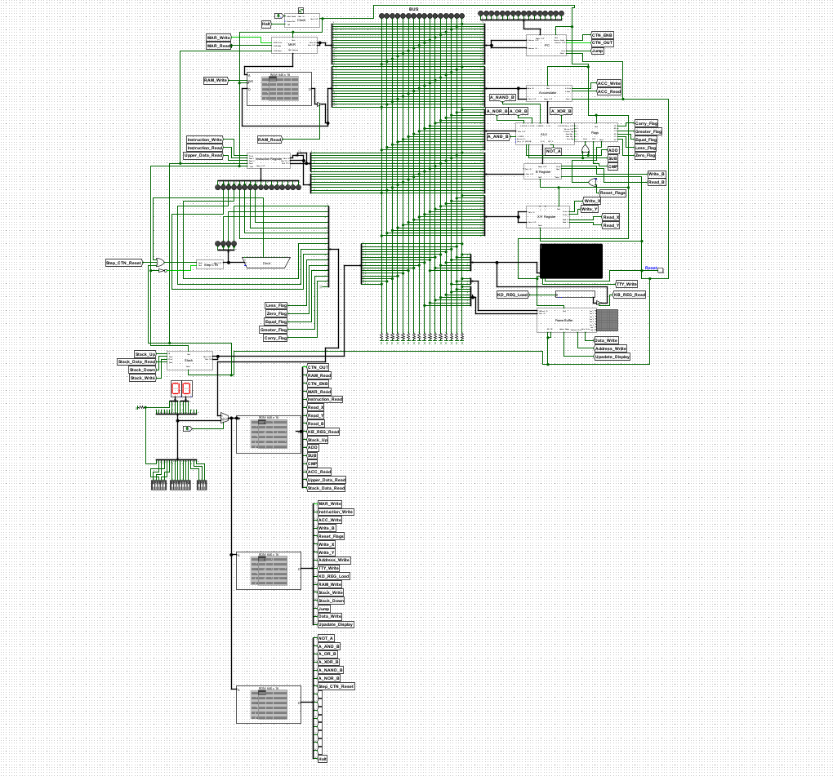

9. Component Details (with Screenshots)

9.1 ALU (Arithmetic Logic Unit)
- Can add, subtract, AND, OR.
- Input: two 16-bit values. Output: 16-bit result.
Screenshot of ALU:
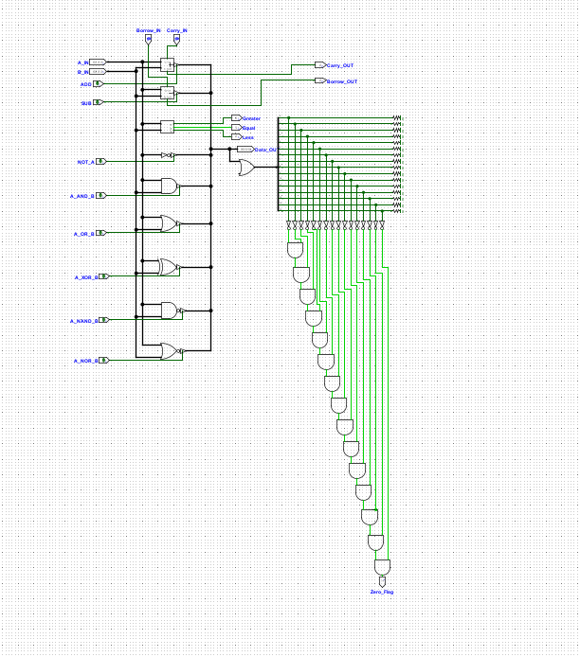

9.2 Registers
- Temporary storage for operations.
- Connected directly to ALU.
- 3 registers are used:
  - B Register
  - Flag Register
  - X and Y Register
Screenshot of B Register:
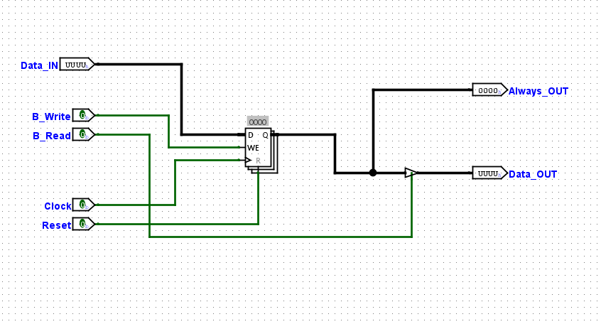

Screenshot of Flag Register:
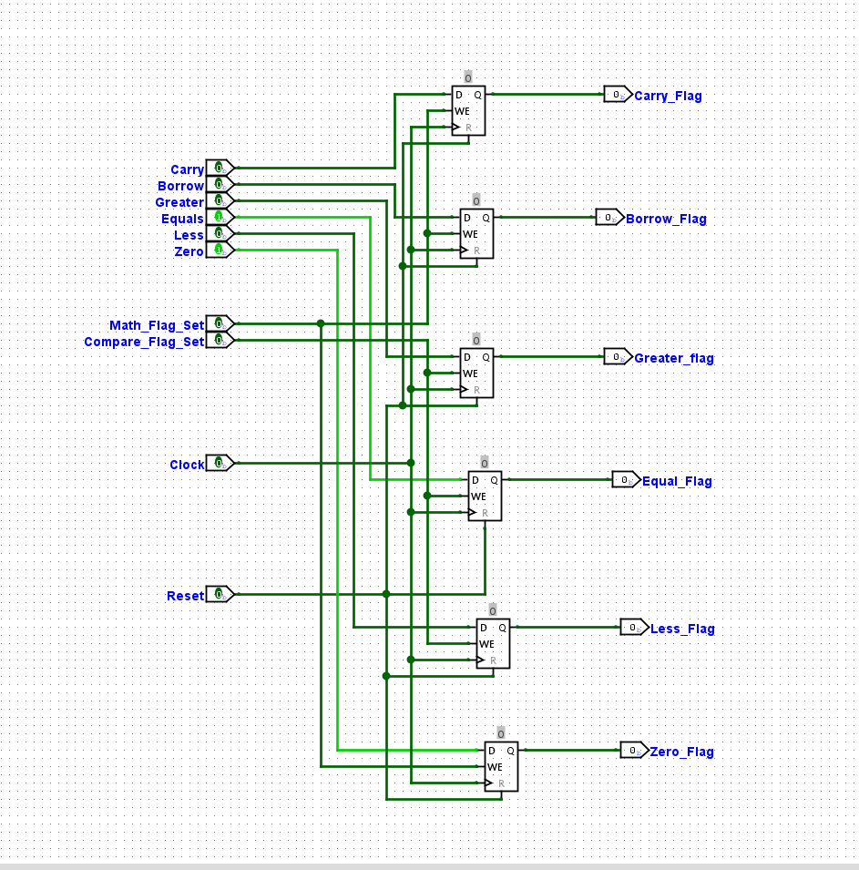

Screenshot of X and Y Register:
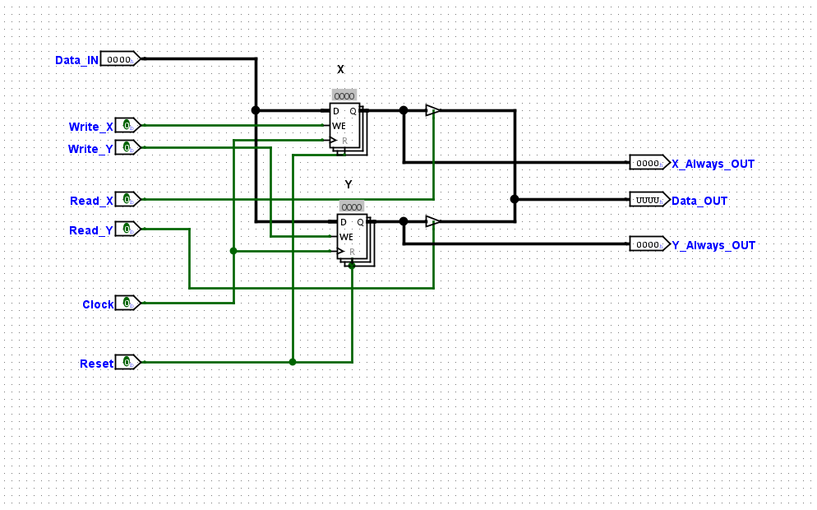

9.3 Program Counter
- 16-bit counter that increases by 1 each cycle.
Screenshot of Program Counter:
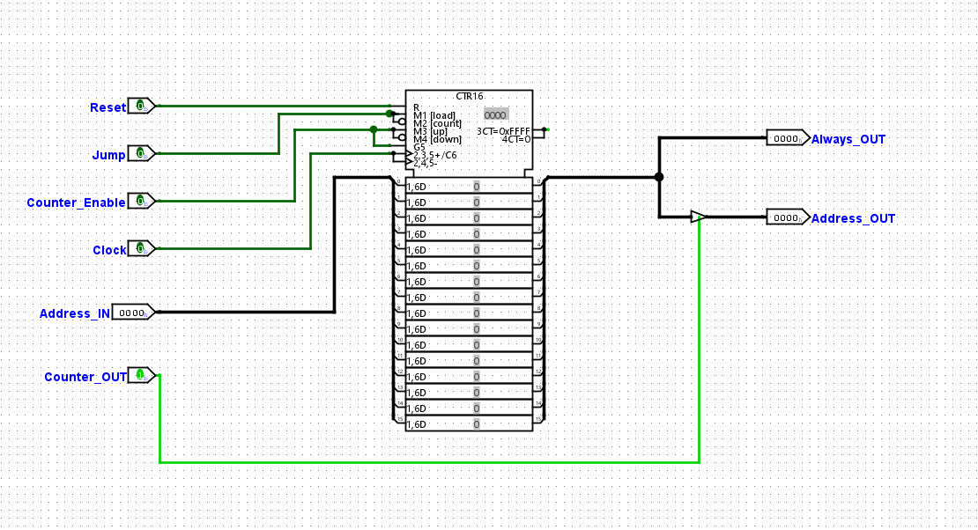

9.4 RAM
- Stores instruction/data.
- Loaded manually in Logisim before simulation.
Screenshot of RAM:
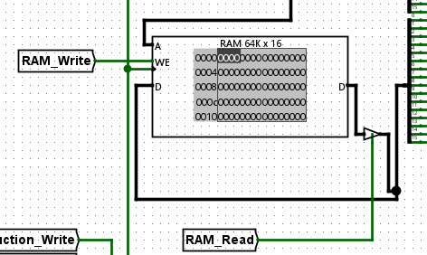

9.5 Control Unit
- Decodes opcode.
- Activates ALU, memory, registers as needed.
Screenshot of Control Unit:
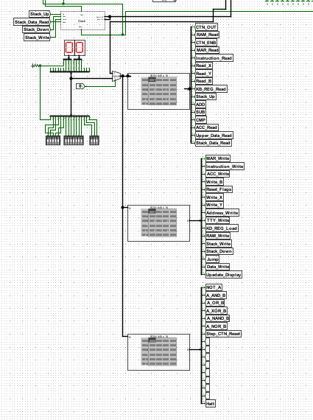

9.6 Clock
- Square wave generator.
- Provides timing pulses.
Screenshot of Clock
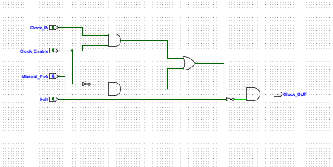

10. Working Explanation
Here’s how our 16-bit computer works step by step - just like a simple version of a real one:
- It all starts with the Program Counter (PC), which points to the first instruction stored in RAM (memory). You can think of the Program Counter as a finger that points to the next line the computer should read.
- The Control Unit reads (or fetches) this instruction from memory and then decodes it to understand what the computer is being asked to do whether it’s a calculation, a data movement, or a jump to another part of the program.
- Based on the instruction, the Control Unit activates the correct components. If a calculation is needed (like adding two numbers), the data is sent to the ALU (Arithmetic Logic Unit) to perform the task.
- Once the ALU finishes the operation, the result is saved either in one of the registers (for temporary use) or written back to RAM (for long-term storage), depending on what the instruction says.
- After completing the instruction, the Program Counter automatically moves to the next instruction, and the entire cycle starts again.
This process keeps repeating , instruction by instruction , in what’s known as the instruction cycle, which includes the following steps:
- Fetch the instruction from memory
- Decode what the instruction means
- Execute the action (like a calculation or data transfer)
- Store the result, if needed
Each part of our computer plays its role in this cycle, and thanks to the clock signal, everything stays perfectly timed. This is how our simple 16-bit computer can follow and run a whole program, one step at a time.

11. Results
Our 16-bit computer was able to run small test programs successfully, including:
- Addition of two numbers
- Subtraction
- Comparison operations (greater than, less than, equal to)
The Arithmetic Logic Unit (ALU) handled all operations correctly, producing accurate results every time.
We also tested data movement operations, such as:
- Loading values from RAM into registers
- Storing values from registers back into RAM
- Transferring data between different registers
Every component we designed , like the program counter, control unit, and memory , worked as expected during the simulation.
One of the most valuable outcomes was that we could observe the full instruction cycle step by step (fetch → decode → execute → store) in action, which helped us understand how real computers work internally.
Since the project was done in Logisim Evolution, we were able to clearly see the flow of data through logic gates, flip-flops, and multiplexers, making the learning process more visual and interactive.
Overall, the computer worked smoothly and performed exactly as planned, giving us confidence in our design and a much better understanding of digital logic concepts.
In short:
- Ran basic programs (ADD, SUB, COMPARE).
- ALU gave correct output.
- Data moved properly between registers and memory.
- All components synced using the clock.
- Full instruction cycle observed visually in simulation.

12. Conclusion
We successfully built a 16-bit computer using digital logic design concepts. Through this project, we learned how computers work at the hardware level, and how different components communicate with each other. It helped us understand instruction cycles, memory operations, and logic circuits in depth.

13. Future Work
We can improve this computer in the future by:
- Adding more instructions. (E.G Jump,Multiply).
- Adding support for input/output devices
- Making a graphical interface for programming
- Adding interrupts and system calls for more realistic behavior

14. References
- YouTube Playlist - DLD Project
- Mano, M. M. (2013). Digital Design (5th ed.). Pearson Education.
- Logisim Evolution Team. (n.d.). Logisim Evolution - Digital Circuit Simulator.

